Creative IT Revision Ideas

Create a key word picture
www.wordle.net

Create a cartoon strip
www.pixton.com
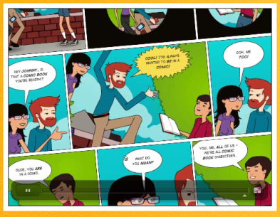

Create a mindmap
www.thinkbuzan.com/uk

Create your own revision website
www.moonfruit.com
www.weebly.com
www.wix.com

Make an animated video
www.goanimate.com

Make a poster using images
www.images.google.co.uk

